NAME: SIVARANJANII.M
DATE:19.08.25 ROLL NO.:241901109

EXERCISE 3
UDP CLIENT-SERVER COMMUNICATION USING SOCKET PROGRAMMING IN PYTHON

AIM:
To implement UDP client-server communication using socket programming in Python.
ALGORITHM:
SERVER:
- Create a socket using socket.socket().
- Bind the socket to IP and port using bind().
- Receive message using recvfrom ().
- Send response using sendto ().
- Close connection.
CLIENT:
- Create a socket using socket.socket().
- Send a message to the server using sendto ().
- Receive response using recvform ().
- Close connection.

CODE:
SERVER:
import socket
sockfd = socket.socket(socket.AF_INET, socket.SOCK_DGRAM)
print("UDP Socket Created")
sockfd.bind(('localhost', 55555))
print("Waiting for messages on localhost:55555")
while True:
data, addr = sockfd.recvfrom(1024)
message = data.decode('utf-8')
print(f"Received from {addr}: {message}")

sockfd.sendto(data, addr)
print(f"Echoed back to {addr}")
choice = input("Continue receiving? (y/n): ")
if choice.lower() == 'n':
break
sockfd.close()
print("Server shutdown")

CLIENT:
import socket
clientfd = socket.socket(socket.AF_INET, socket.SOCK_DGRAM)
server_addr = ('localhost', 55555)
msg = input("Enter your message: ")
clientfd.sendto(msg.encode('utf-8'), server_addr)
data, _ = clientfd.recvfrom(1024)
print("Echo from server:", data.decode('utf-8'))
clientfd.close()
OUTPUT:
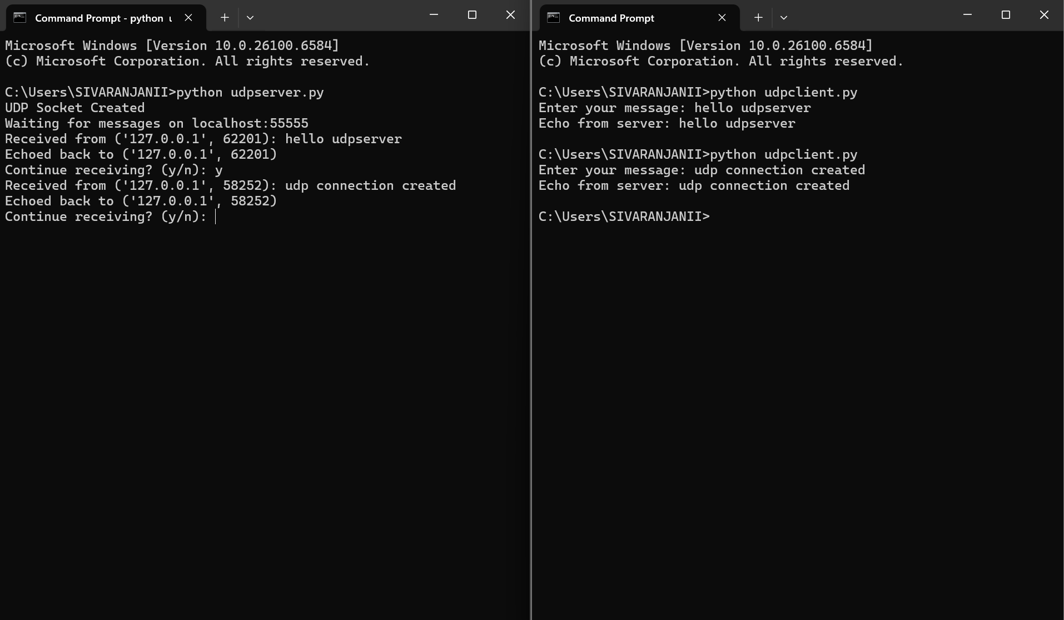

RESULT:
Thus, UDP client-server communication was successfully implemented using Python.

